**Click-O-Sites (SEC portals)**

**Algorithm to setup:**

1. Download this **Zip file in your OS.**
2. Go to **Chrome** if you are a chrome user
3. Click and go to customize button on **top right corner** and click on **more tools**

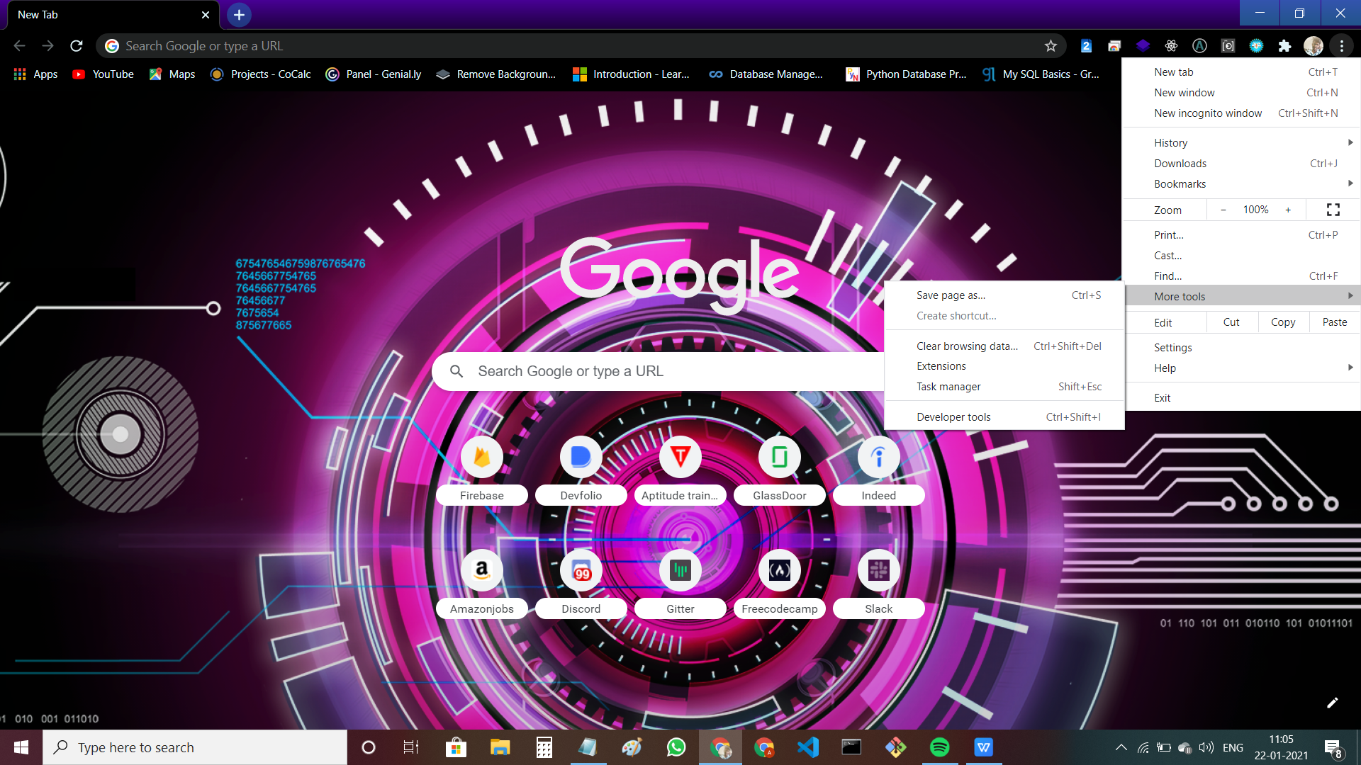

1. Go to **Extensions**

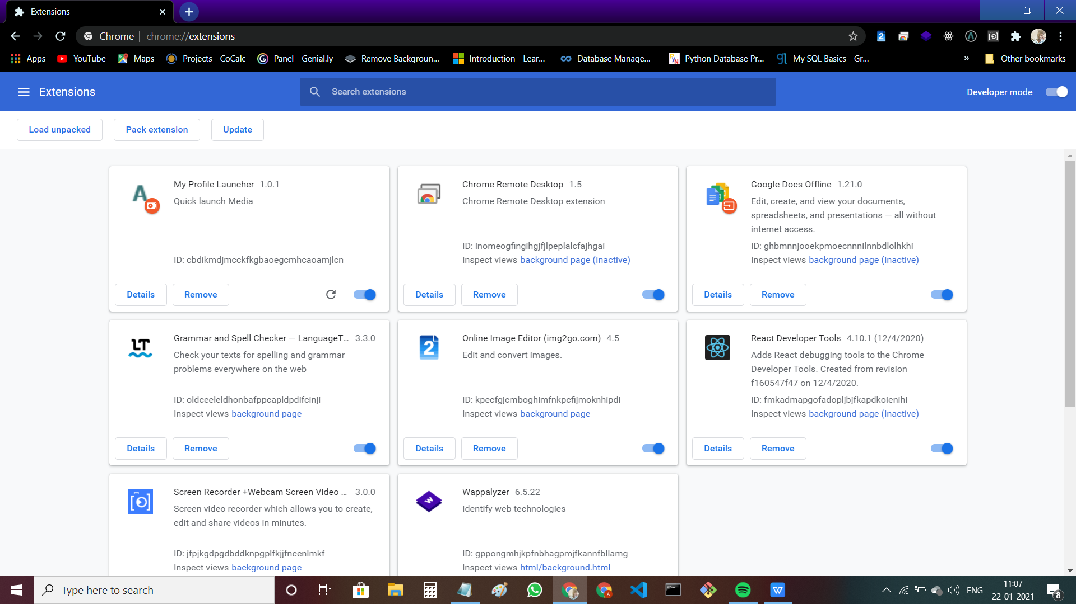

1. After that click on **Load unpacked tab** on top left

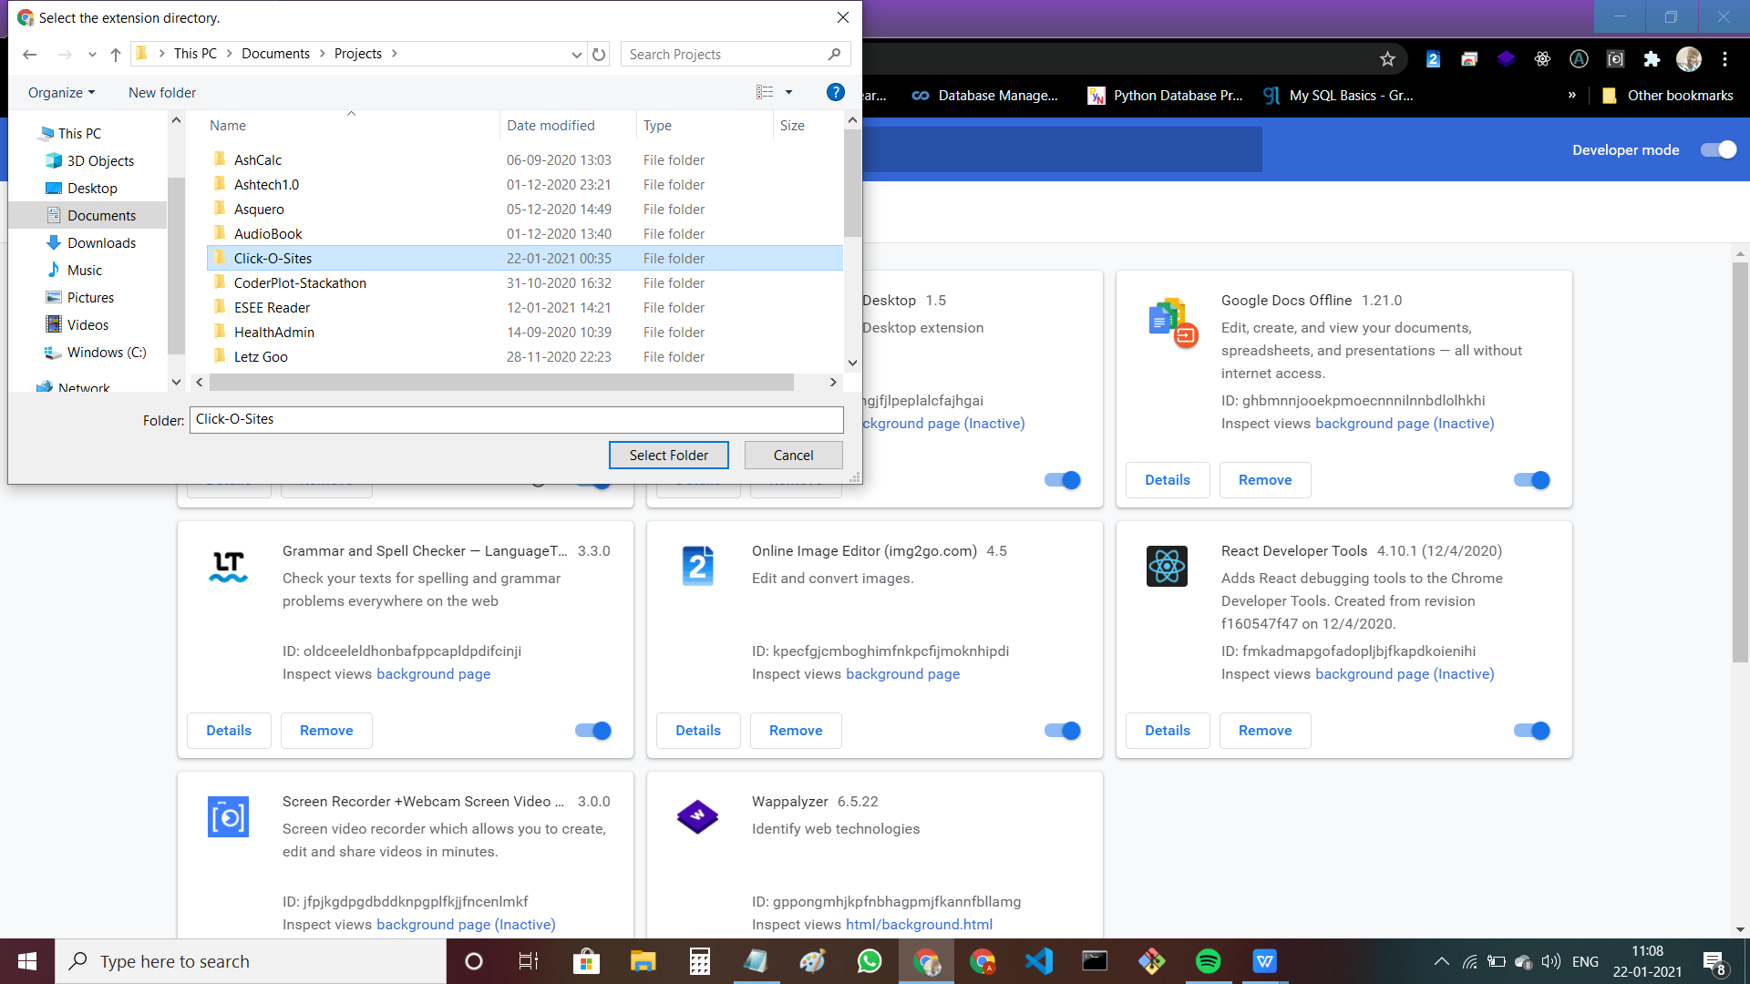

1. Select that zip file and click **select folder.**

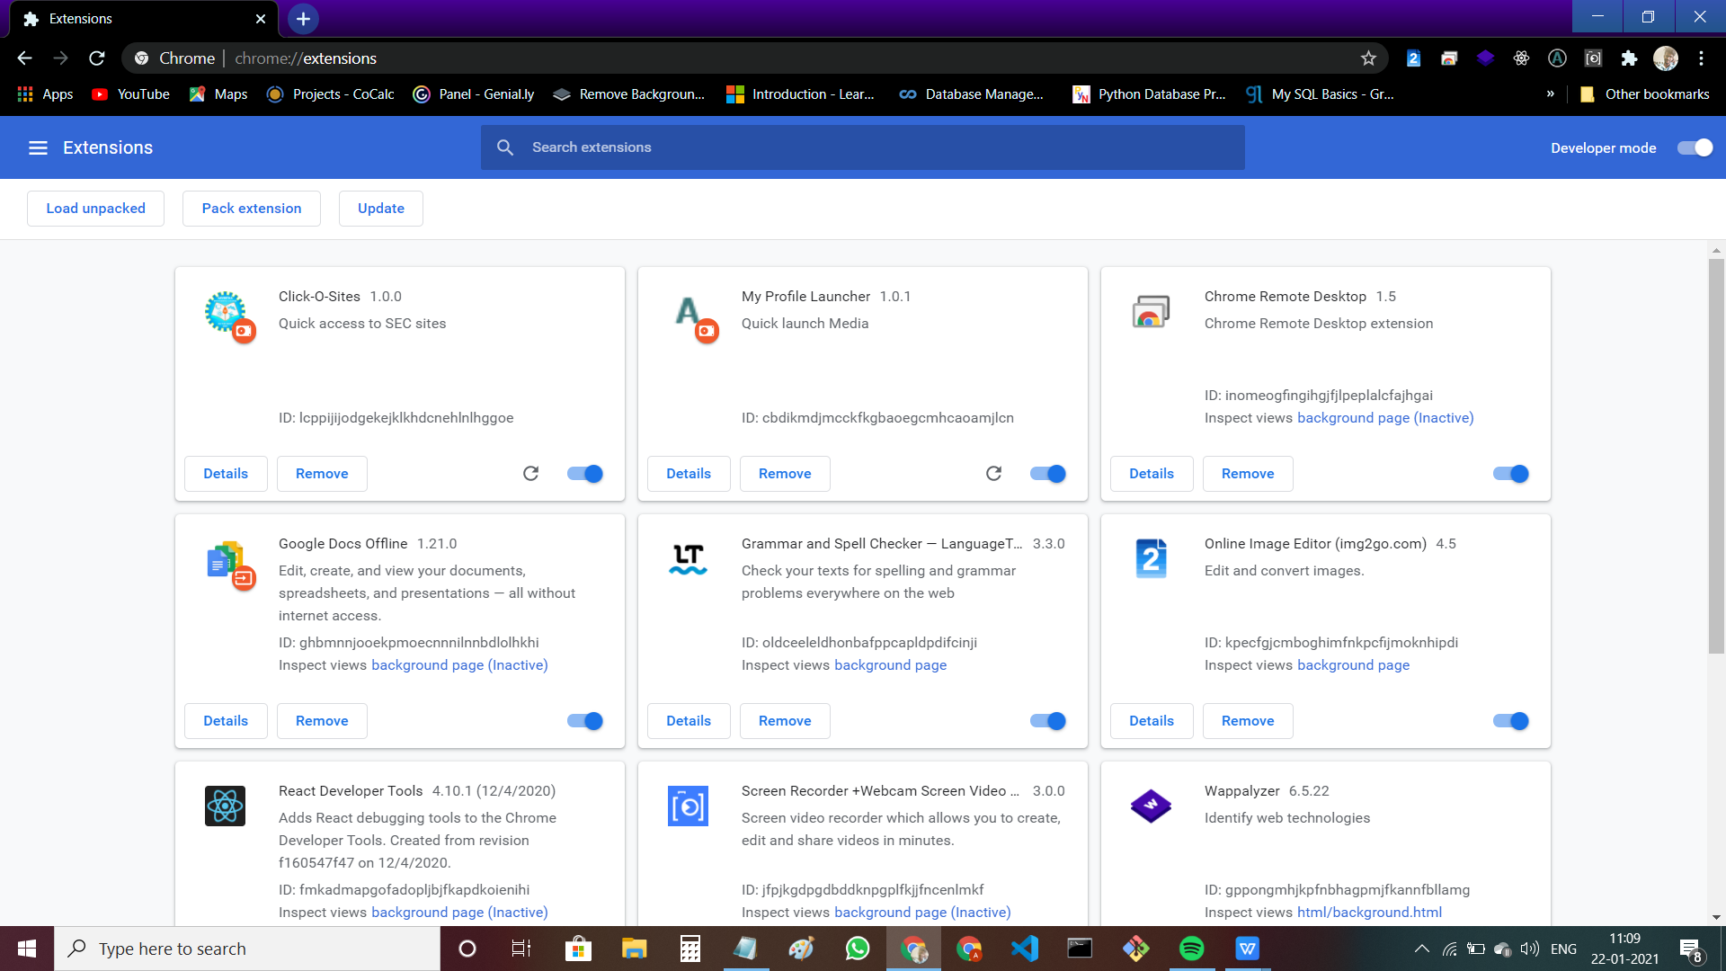

1. Alright now our Click-O-Sites chrome extension fixed in our chrome browser
2. Now go to new tab and click on  **extension icon.**

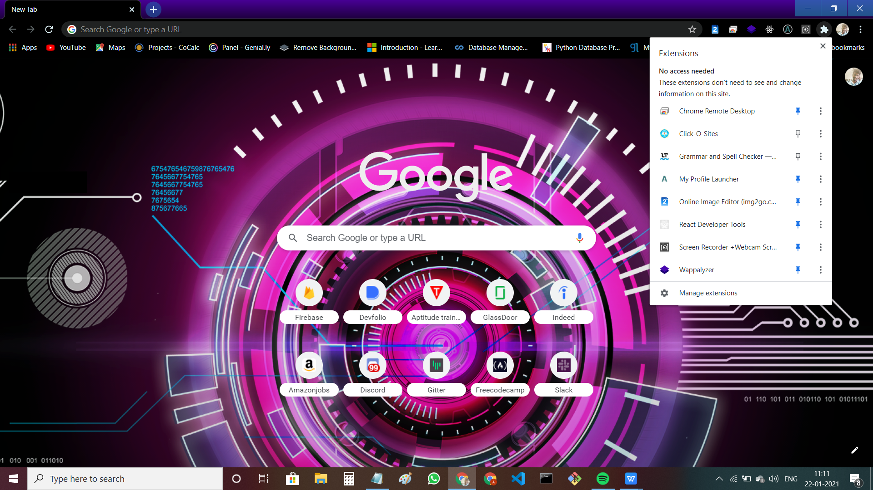

1. pin our extension
2. Hip hip hurray now our extension perfetly works !!!

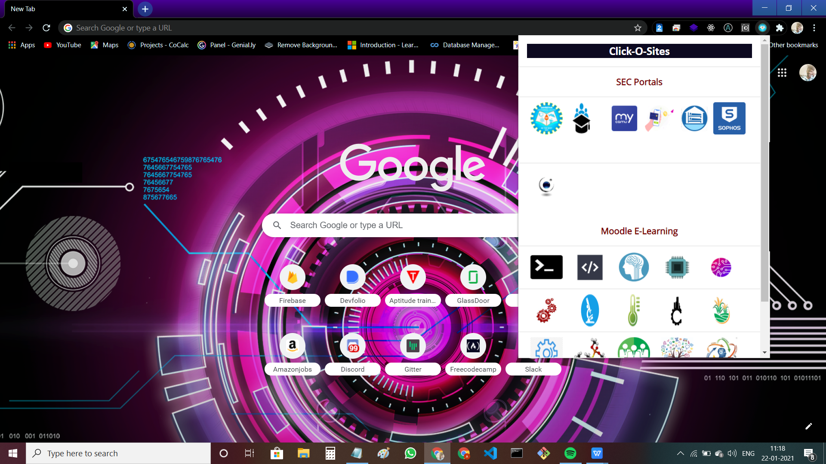

**How to use**

1. Click the **edit** button

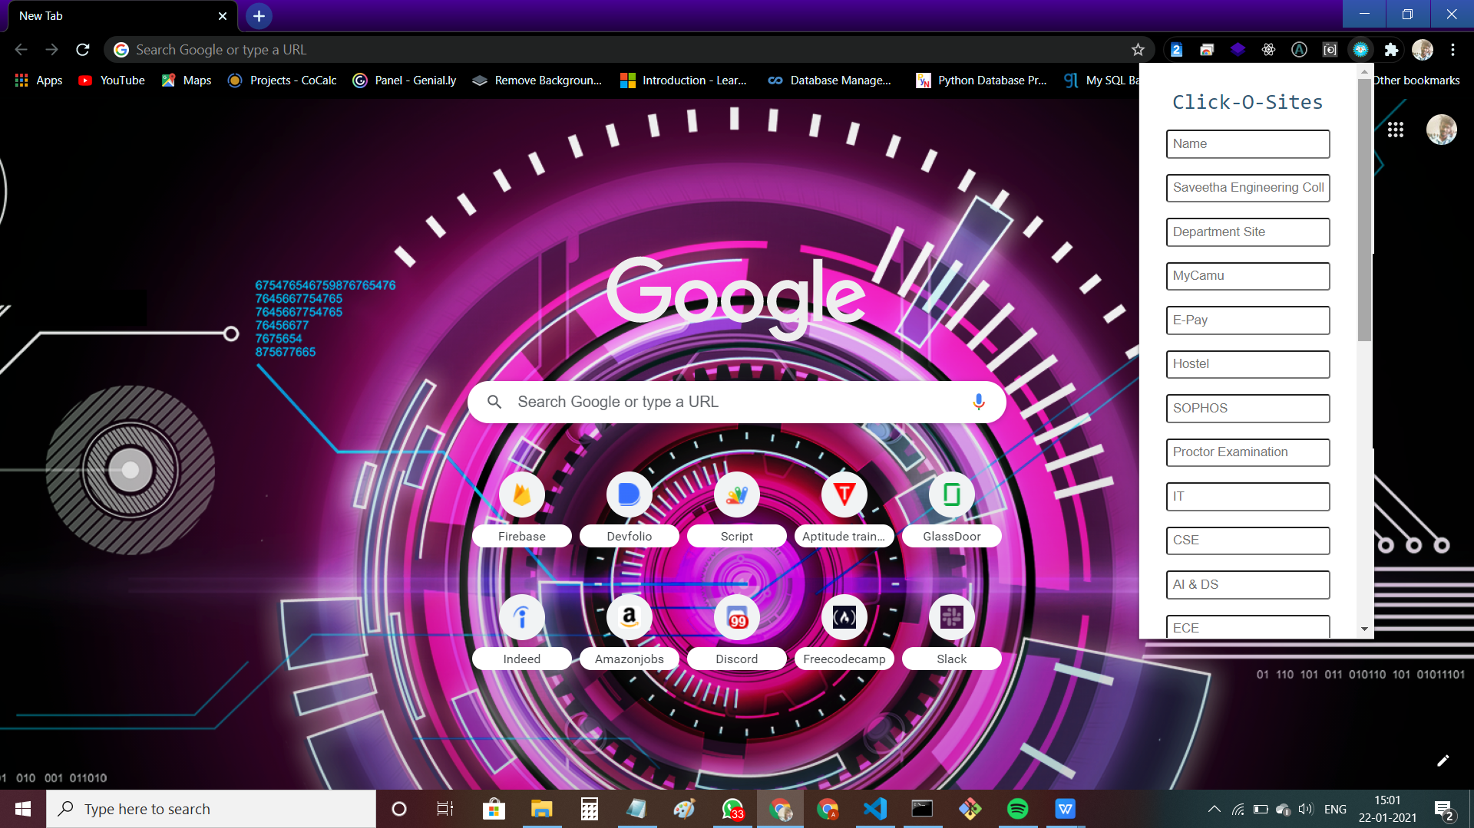

1. **Paste the links** on respective fields and **save** it

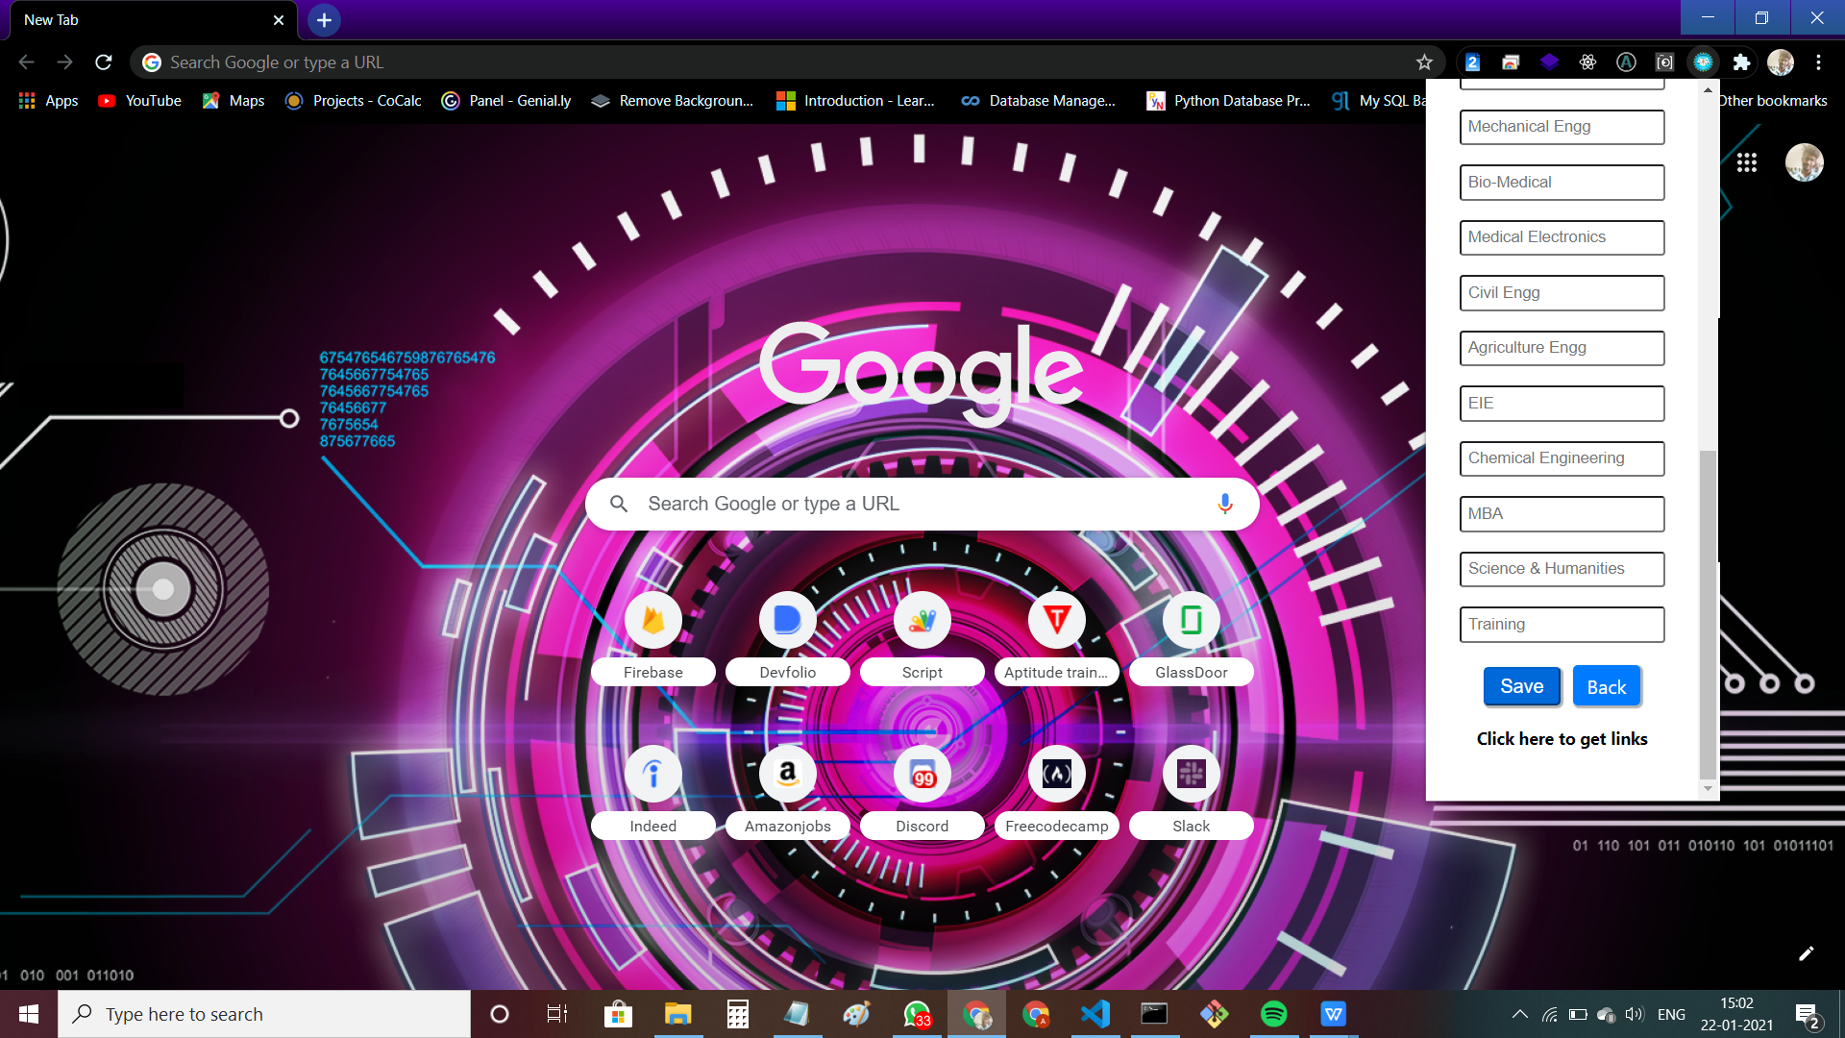

1. If don’t know the link just **click the get links with new tab** and refer your links.

**Thank You !**

**Ashwin Kumar R**